Devin Hardy

Dhardy2@my.athens.edu

00076619

ASG7

1. A.

B.

C.

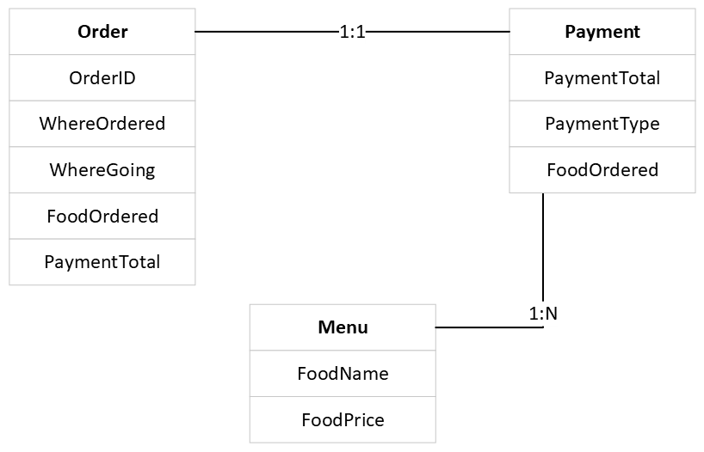

D.

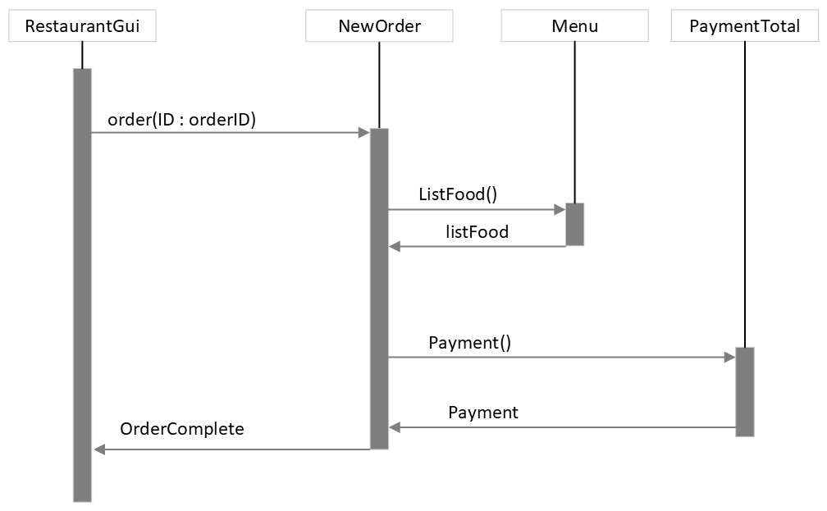

E.

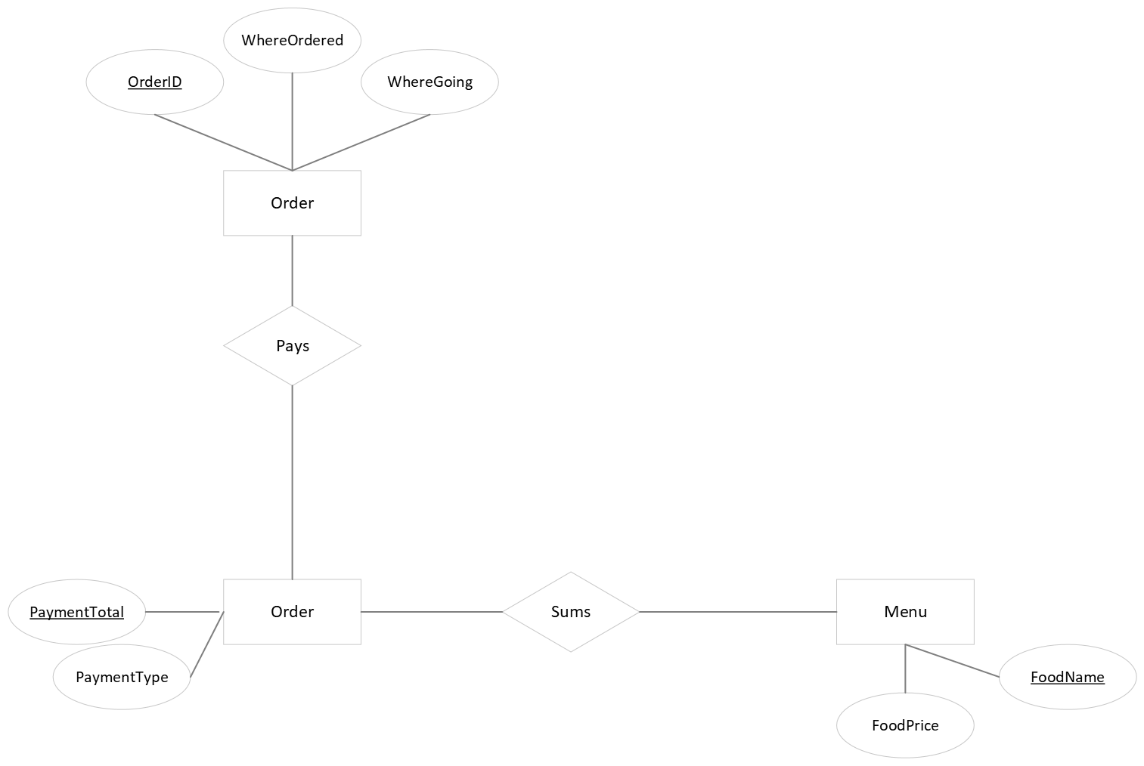

F.

1. Ran out of time
2. n1 = 28; n2 = 48; N1 = 250; N2 = 132

V = N \* (log2 n) = 2133.45567

V@ = (2 + n2@) log2 (2 + n2@) = 98.10750

L = V@ / V = 0.04598525

E = V / L = 46,394.3475

1. E – N +2P

E = 10; N = 8; P = 1

10 – 8 + 2

Cyclomatic complexity = 0